Results of using GPP and NLD (as implemented in CEPS) on file ECG_BC_c_25_8.hrv.txt (227 data points)

[General Note: Please can you check the labels and other wording in the CEPS screenshots here, and suggest corrections/changes where you feel they are not suitable]

A. GPP Symmetric

GPP results are displayed in two panels:

* Kalauzi GPP Sym
* GPP Sym Data

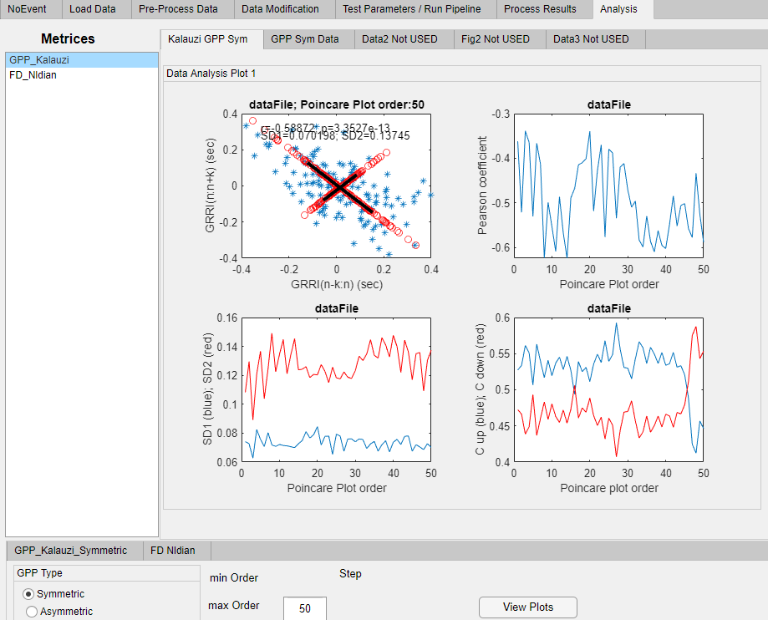

Obs 1. Can you provide a general caption that would be useful to explain these 4 plots?

**Up left:** Generalized Poincaré Plot (GPP) (blue asterisks); their projections on two diagonals (red circles); 2xSD1 and 2xSD2 (black lines, along and away from the main diagonal, respectively). THEY ARE TO BE SWAPPED IF YOU USE THE NEW VERSION “gppsymcor”. SEE MY NEW INSTRUCTION.

**Up right:** Pearson’s coefficient of linear correlation of the GPP cloud as a function of the GPP order

**Down left:** Dependence of SD1 and SD2 on the GPP order

**Down right:** Dependence of Guzik’s asymmetry parameters Cup and Cdown on the GPP order

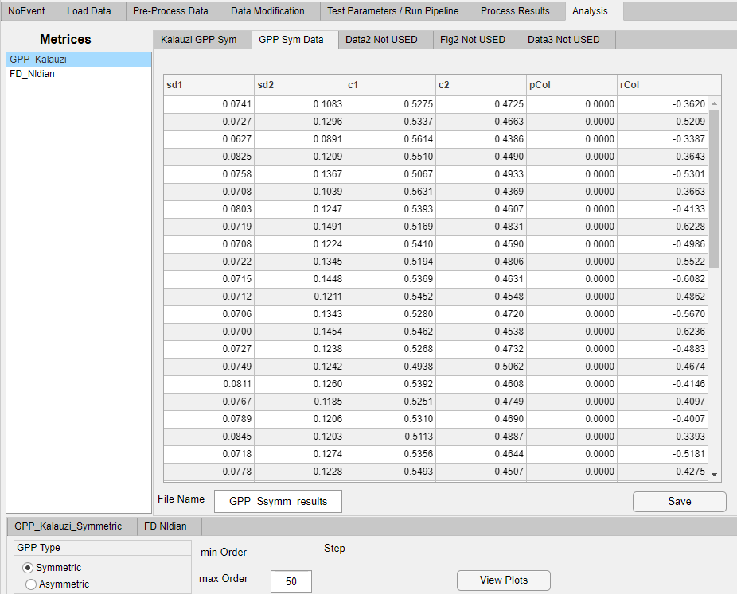

Obs 2: Are the headers correct? Would it be possible to explain pCol [presumably the p-value for the corresponding value of Pearson’s r] and rCol [Pearson’s r?]?

It would be better to denote c1 and c2 as Cup and Cdown in order to be consistent with the previous results figure. Yes, p is the statistical significance of the Pearson’s coefficient. There is no need to keep the suffix “Col” in both names; “r” and ”p” would be enough.

Results available in ‘GPP_Ssymm_resuits.xlsx’.

B. GPP Asymmetric

GPP results are displayed in three panels:

* Kalauzi GPP Asym
* GPP fcoef
* GPP maxmatss

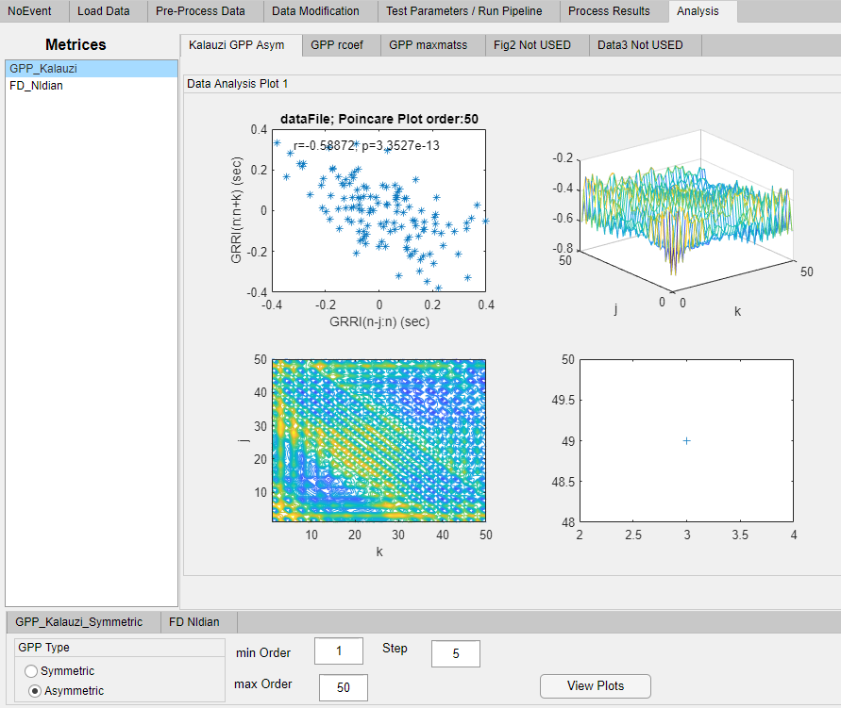

Obs 3: There are no captions to the four figures here. If you can provide them, that would be helpful.

According to my previous Instruction, there should be three panels, not four. Therefore, I will suggest captions according to that.

**Upper left:** GPP cloud for maximal GPP order (somebody centred the GPP clouds around zero? Please “uncenter” them so that axe labels would be correct)

**Upper right:** Matrix of Pearson’s coefficients of linear correlation, r(j,k), for each combination of GPP order indexes

**Lower left:** Contour map of the r(j,k) matrix with local extrema indicated with crosses

C. NLD

Obs 4. Can you suggest alternative names to NLD ‘ian’ and ‘wan’. Maybe something like NLD_mov and NLD_all would be easier to remember? Or …

OK, I agree

In CEPS, my colleague Deepak Panday has included NLD in the ‘Test Parameters’ section in CEPS:

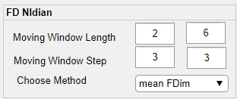

The results look like:

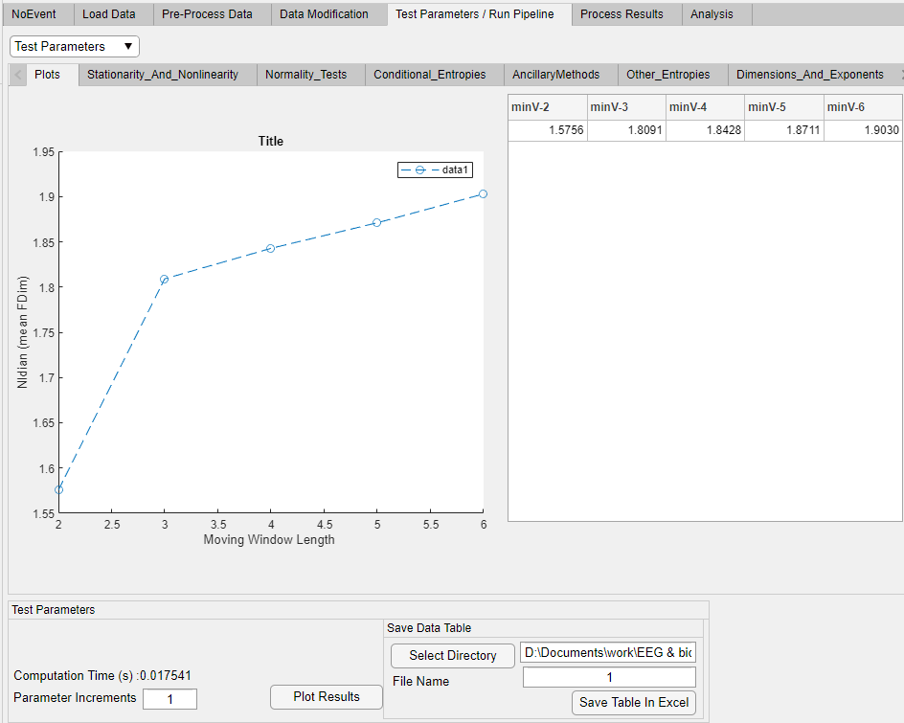

Or like this for multiple files:

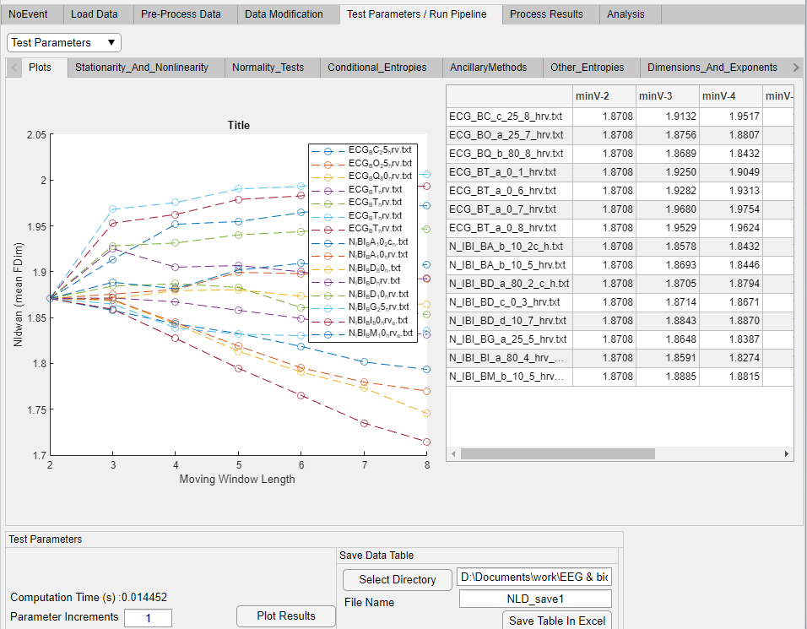

Obs 5: Please can you explain the meaning of ‘minV’.

According to the context, “minV” seems to bear the meaning of “Moving Window Length”, although I don’t see why this acronym.

May I suggest that, although I devised this method for short windows, calculating FDim for such an extremely short window length as 2 has no physical meaning. How can you assess and compare quantitatively complexities of two straight lines? Therefore, I suggest starting from minimal window length of 10 samples. This degenerated situation can be clearly seen in the previous panel where all FDims have the same value at 2. I expect them to stabilize, for each signal, for window lengths > 10 samples.

He has also included NLD in the ‘Analysis’ section (as for GPP):

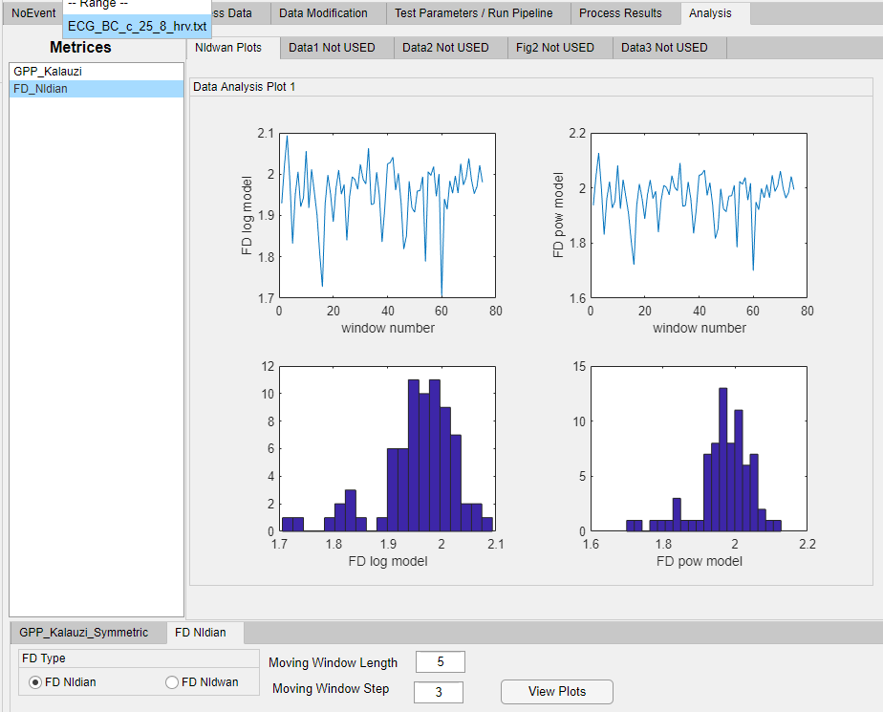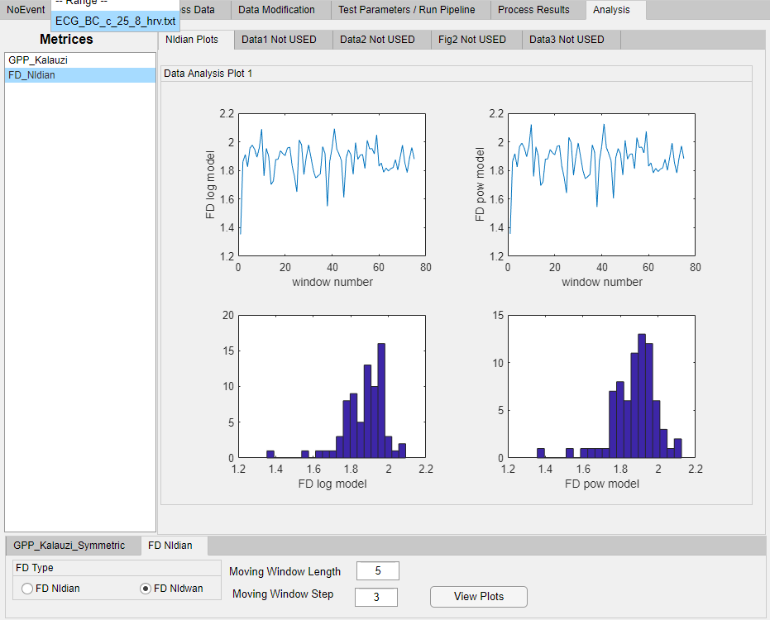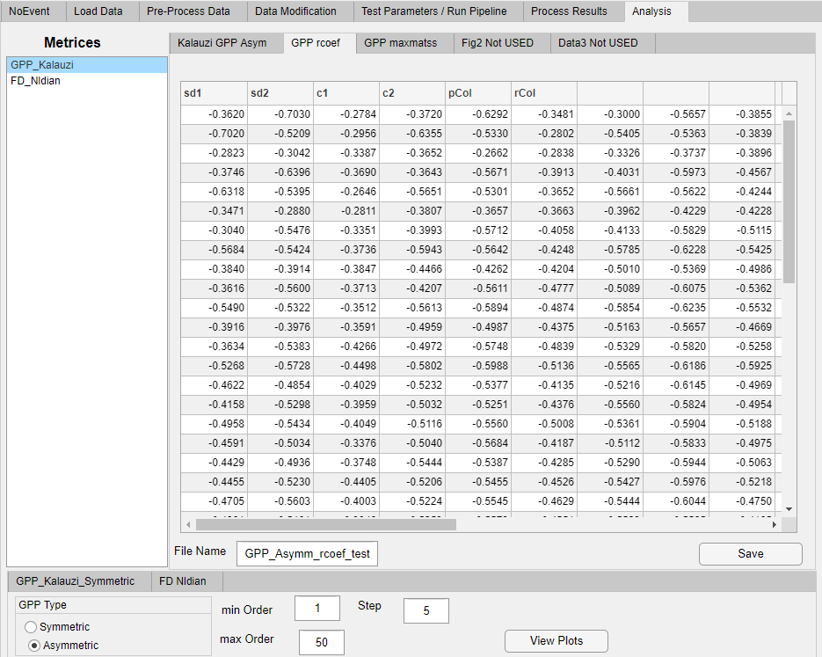

Obs 4: Only the first 5 columns in the Table have headers. Can you suggest headers for the other columns?

All these 5 headers are wrong and should be removed. However, “GPPrcoef” card label is right and what we see here are particular r(j,k) values, part of a matrix obtained in an asymmetrical analysis. If necessary, columns and rows should be labelled with “j” and ”k” (number of previous and subsequent RRI). However, whether columns should be labelled with j and rows with k (or vice versa), could be determined by comparing (j,k) positions of local maxima (crosses) on the contour map and finding those maxima in the matrix (please see my previous Instructions where “johndoerpo” was analyzed). Or, even better, use data from “GPP maxmatss”, the 3 column result of detecting all r(j,k) matrix local maxima.

My program also calculates “NAI” (Normalized Asymmetry Index), a very concise and useful quantification of the asymmetry of the r(j,k) matrix. I hope it is included in the results.

Results available in ‘GPP_Asymm_rcoef_test.xlsx’.

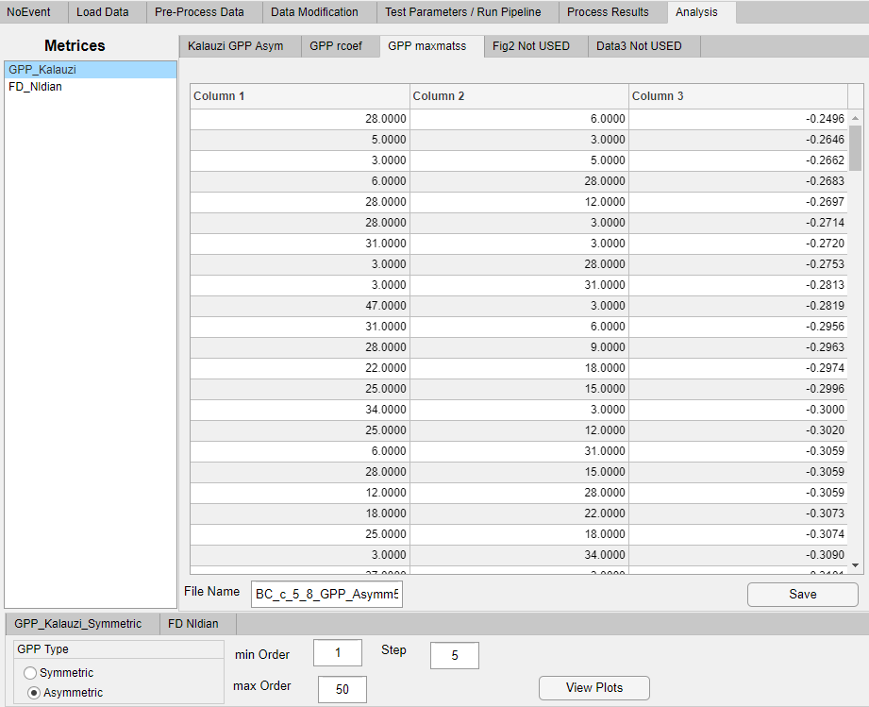

Obs 5: There are no headers here. Again, can you suggest headers for them?

Yes, this is the result od detecting all r(j,k) matrix local maxima. Each row presents the next detected maximum. Therefore, number of rows corresponds to the number of maxima. The first two columns refer to the “j” and “k” coordinates of the maximum, respectively, while the third column is the r(j,k) value at the maximum. Suggestion for labels: “jmax” (or only “j”), “kmax” ( or“k”), rmax, respectively.

Obs 6: And is it possible to explain why there are 215 rows in the Table/Excel output file?

Your short file did not generate a “smooth” matrix, therefore so many local maxima. Compare to the contour map of “johndoerpo” which had only 4. This report is printed at the end of program execution.

Results available in ‘BC_c_5_8_GPP_Asymm50,1,5.xlsx’.